Hornet Pit Assembly and Disassembly

Table of Contents
Disassembly 1
Remove Skins 1
Remove UIP Cover 3
Remove Canopy Bow 5
UIP 7
Power Distribution Panel 7
Disconnect Port/Left Console 8
Disconnect Cables 8
Disconnect Starboard/Right Console 9
Disconnect Cables 9
Remove Seat 10
Disconnect Cable 10
Remove Rear Support Cross Member 10
Remove Seat Base Screws 10
Remove Stick USB cable 10
Lower seat rollers 10
Slide Seat out 10

Disassembly

Remove Skins
Remove screws from the bottom up, once on the top work from the edges towards the centre. Press against the skin to hold it in place while removing the last two screws.
Disconnect strobe and formation lights.
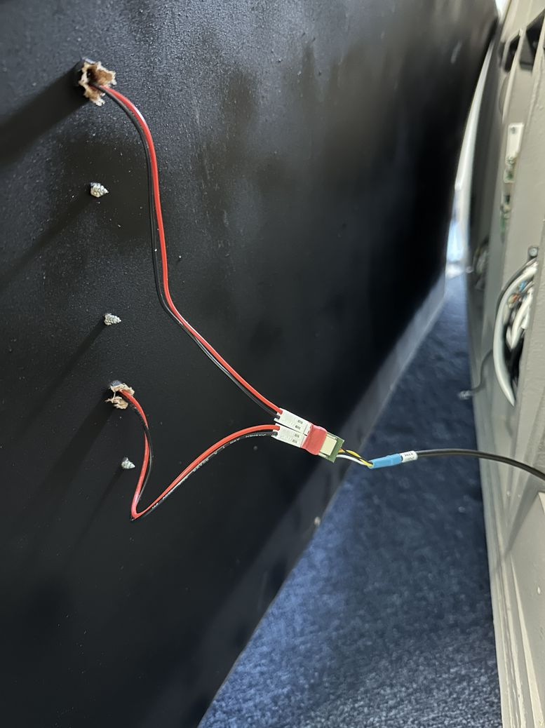Figure 1: Port Rear Skin | 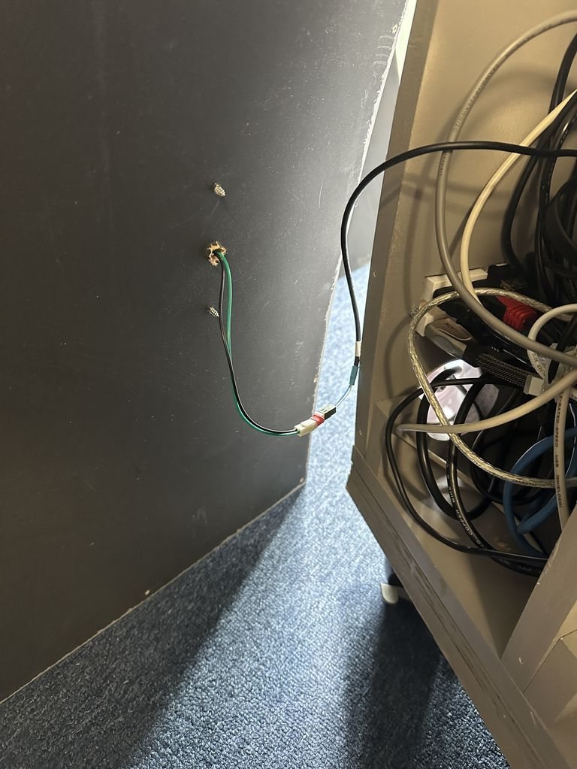Figure 2: Port Forward Skin
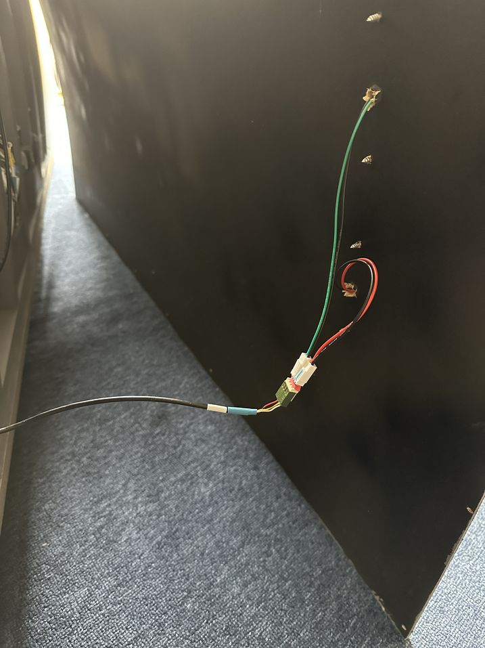Figure 3: Starboard Rear Skin | 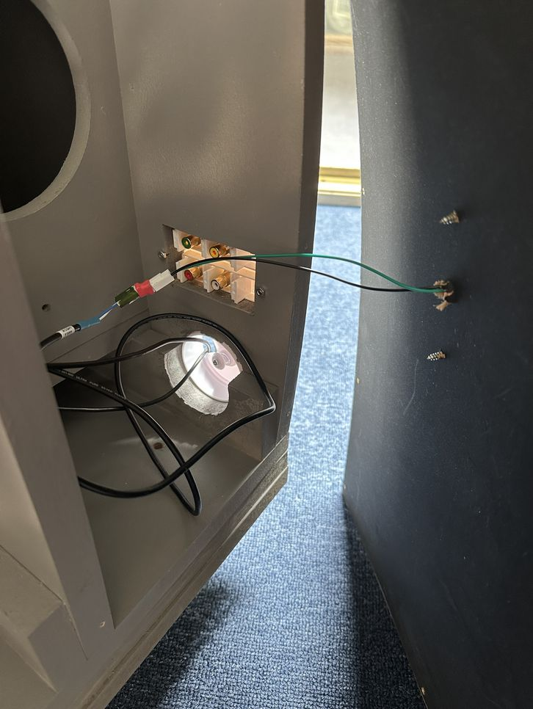Figure 4: Starboard Forward Skin

Remove UIP Cover
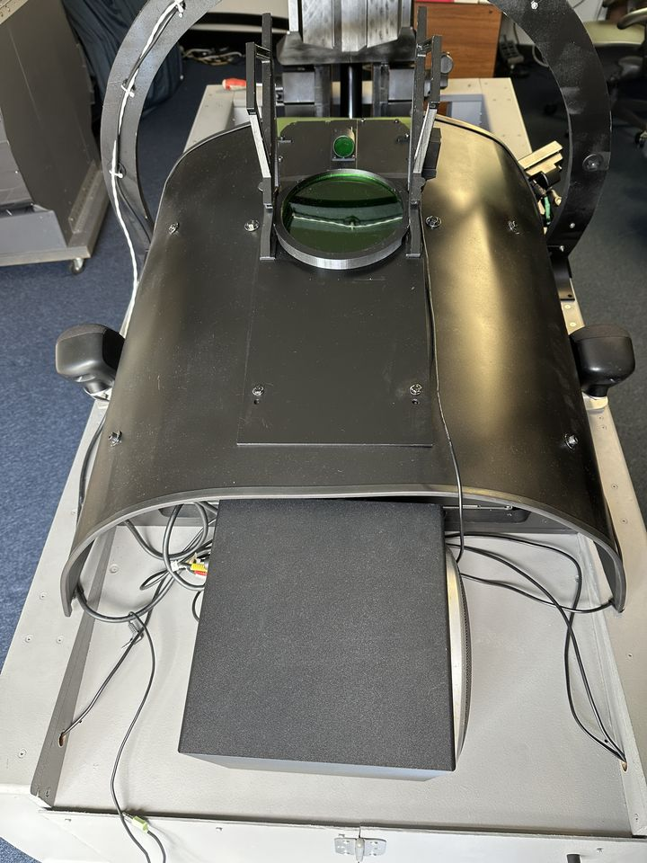Figure 5: UIP - Forward Section

Remove the two bolts for hud assembly, the AOA indicator is just sitting in its holder. Place AOA indicator forward shelf.
Place the port speaker on the forward shelf
Rotate the two positioning clips on the hud | 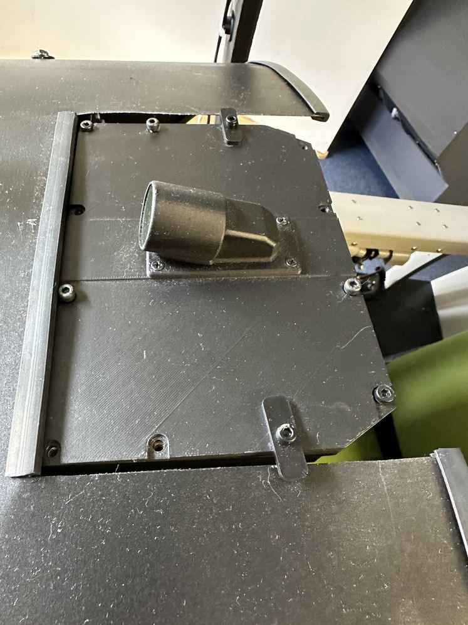
Remove the bolts holding the cover, starting from the port side working towards the starboard side. | 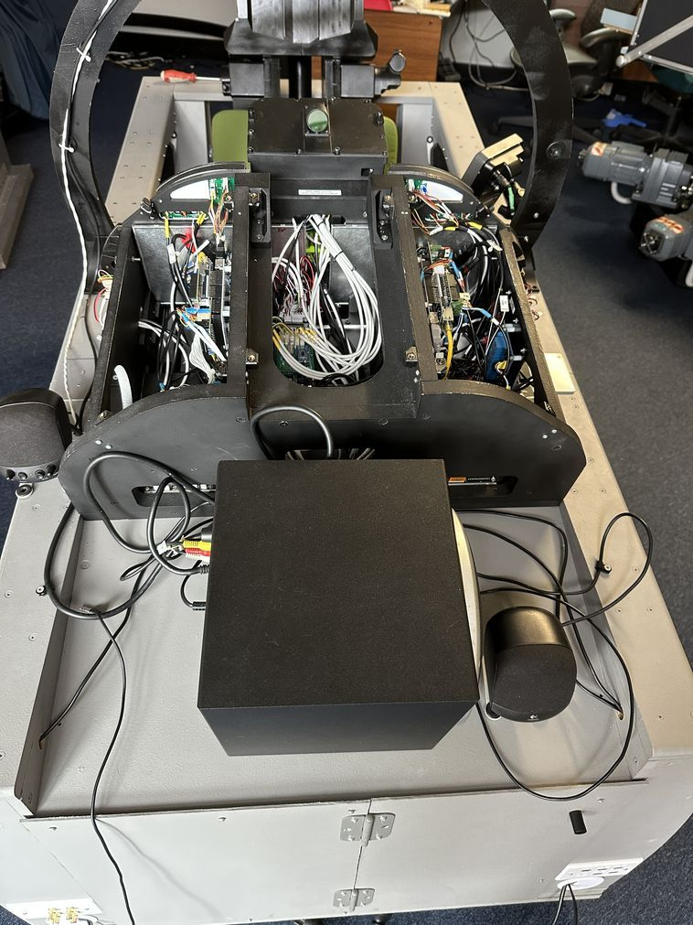
Remove port and starboard upper alignment plates | 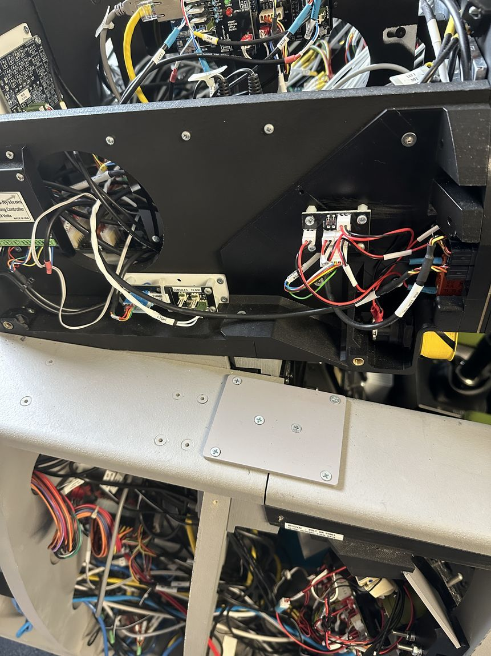

Remove Canopy Bow
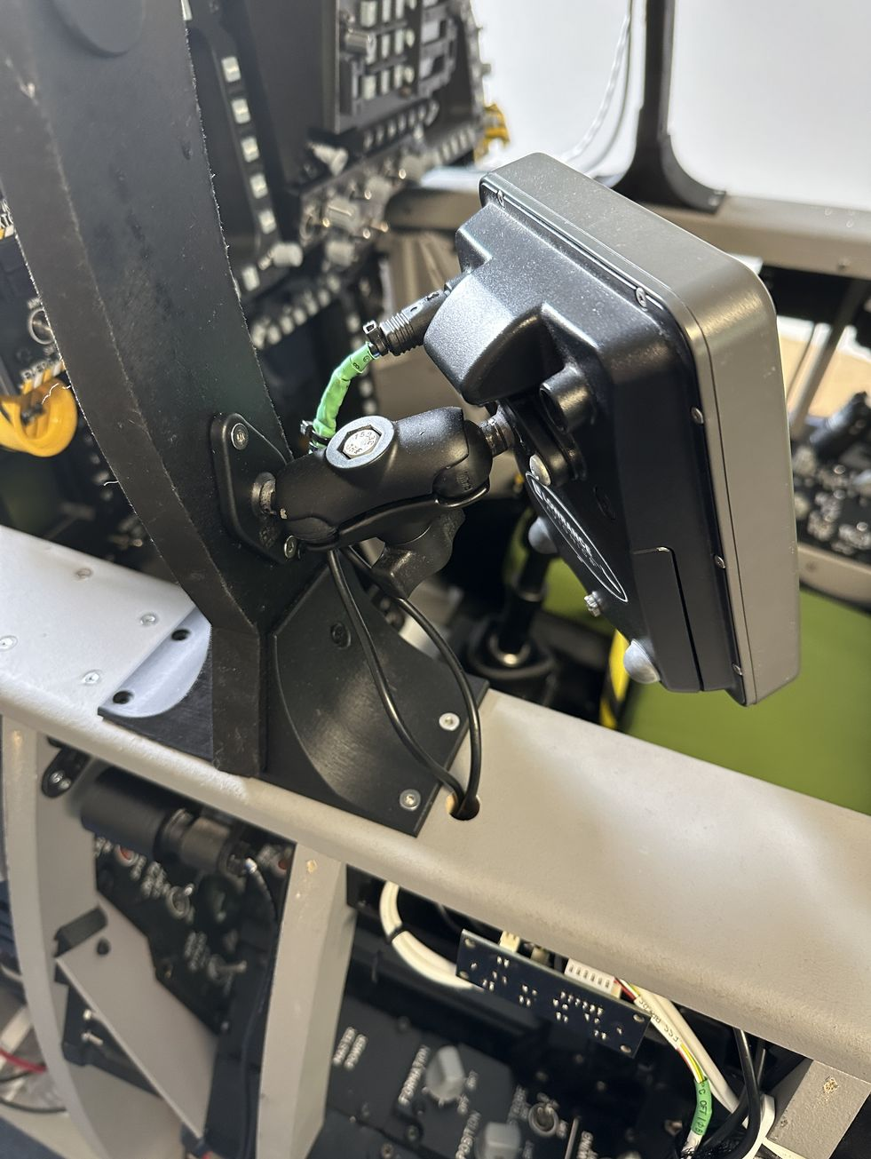 | 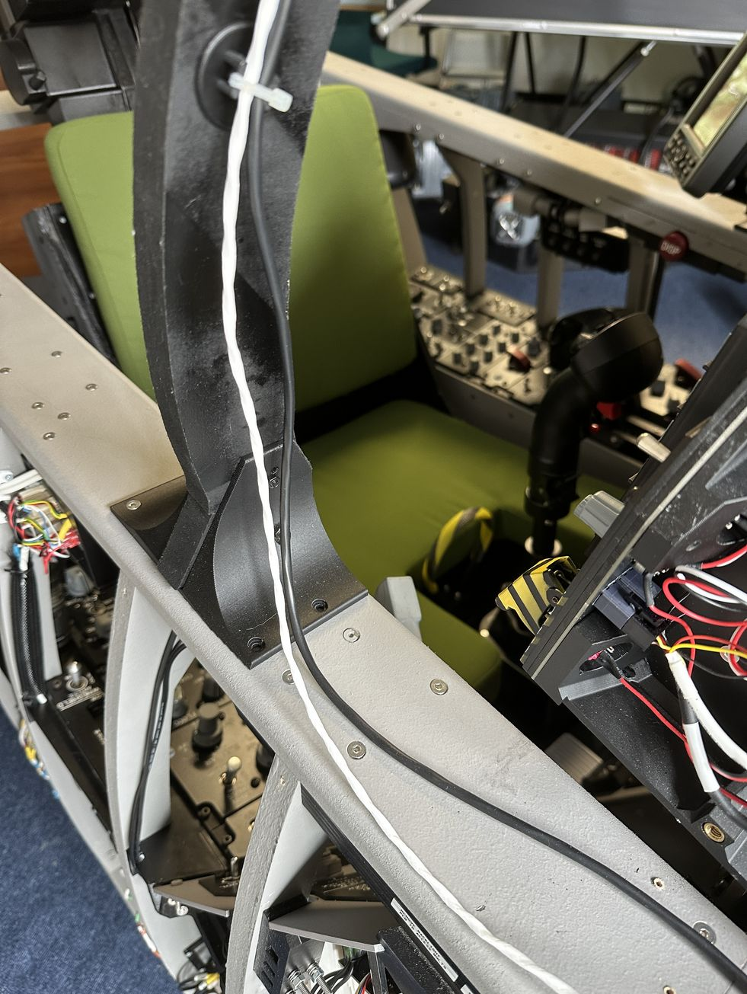
Unplug the connector to the GPS.  Remove the GPS.  Lift the cable glad to the Lock-Shoot and Bow Chart Light can be removed.  The cable path for the Lock-Shoot cable rises back into the LIP on the starboard side and traces directly to the LED distribution PCB. | 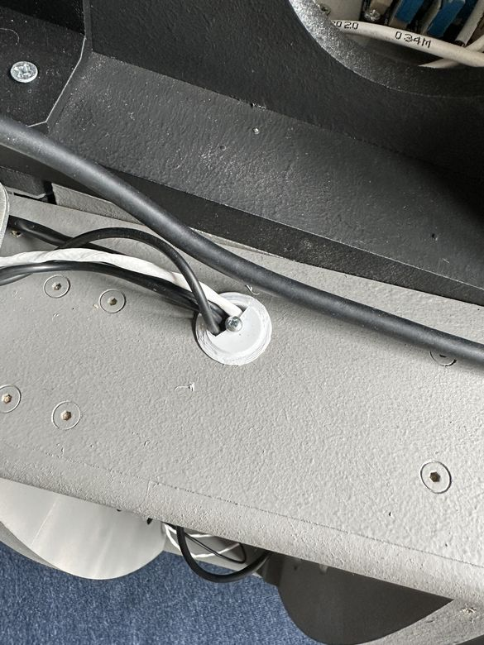
The chart light follows a similar path to the Lock-Shoot, terminating on the PWM distribution pane. | 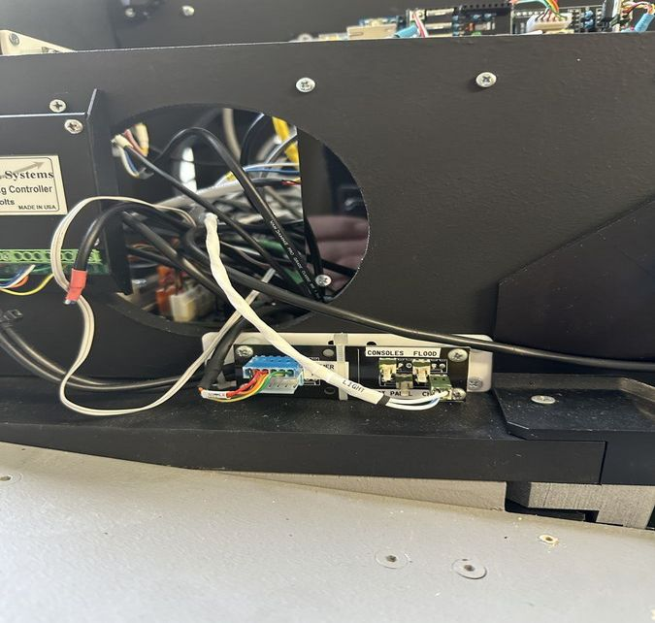
The cable slack for the chart light lives in the LIP | 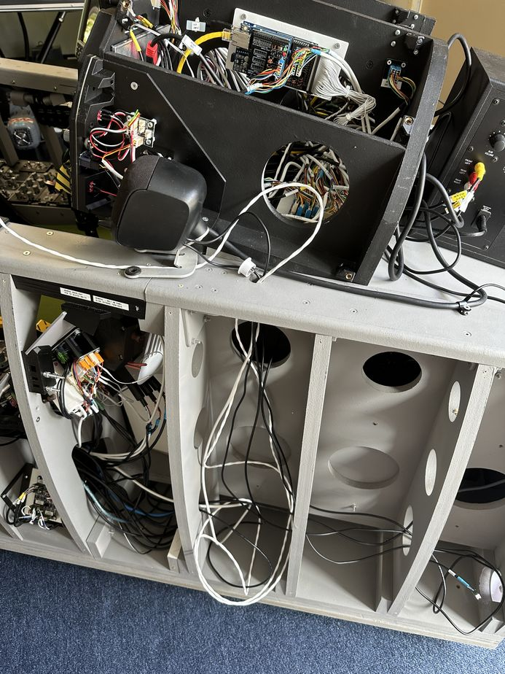

Disconnect cables from the LED distribution board
Disconnect the Map Light cable from the PWM light distribution panel in the UIP
Disconnect the Compass cables
Unscrew the Canopy bow itself
Remove the canopy bow support brackets

UIP

Power Distribution Panel
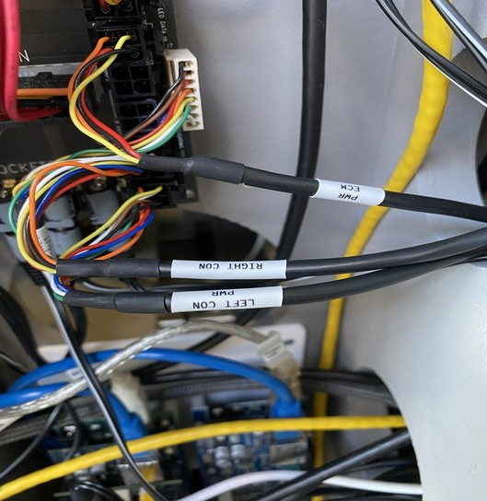

Disconnect Port/Left Console
Note there are nuts located midway along the bolt (between the console and UIP) that hold the bolt in place.
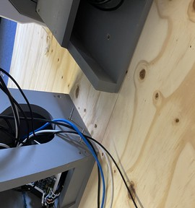

Disconnect Cables
USB | Bone | Bone
Port Side PWM | Black | Green
Left console Flood left console
12V | Black | Red
Left Console Stepper Servos | White | Yellow
Left Console Digital Out | White | Red
Left Console | Black | Orange

Disconnect Starboard/Right Console

Note the nuts sitting midway along bolts to hold the bolt in position
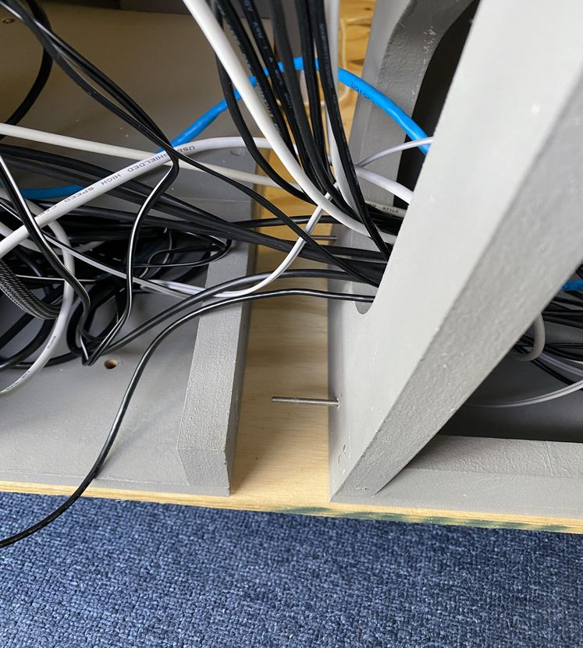

Disconnect Cables
The cables stay attached to the console
Role | Cable Colour | Connector
Ethernet | Blue
Right Conn Power | Black
Strb Side Dimmer | Black | 4 way Green
UFC Analog | White
Right Console LIP Servos | Black | 6 way Yellow
Right Console LIP Digital | Back | 6 way unpainted
Right Console LED | Black? | 4 way Orange
Right Console LIP Stepper | Black
Dimmer Pots | Black | Blue
USB | Blue
12V | Black | Red
These could be left console
Something Power (utility light?) | Gray/Black | 2 way unpainted
Ethernet | Blue
Backlighting | White | 4 way Black
USB | Bone

Remove Seat
Disconnect Cable and place it on seat cushion to prevent it becoming entangled.  Remove the port and starboard bolts which lock the extended support arms in place.  Remove the four screws (two forward, two aft) which attach the seat to the floor, an extension  shaft will make it easier to remove the two forward screws. | 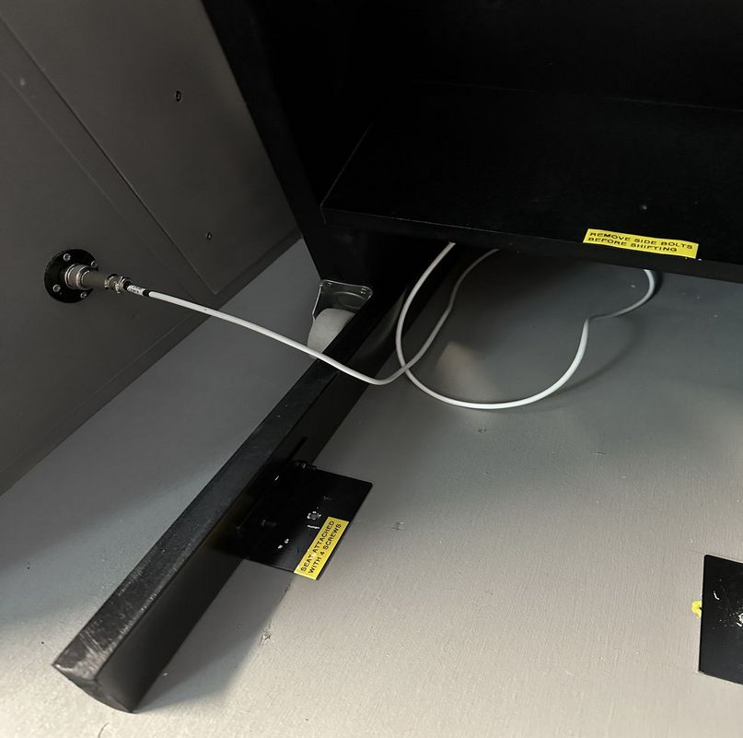
Unplug Stick USB connector.  Slid | 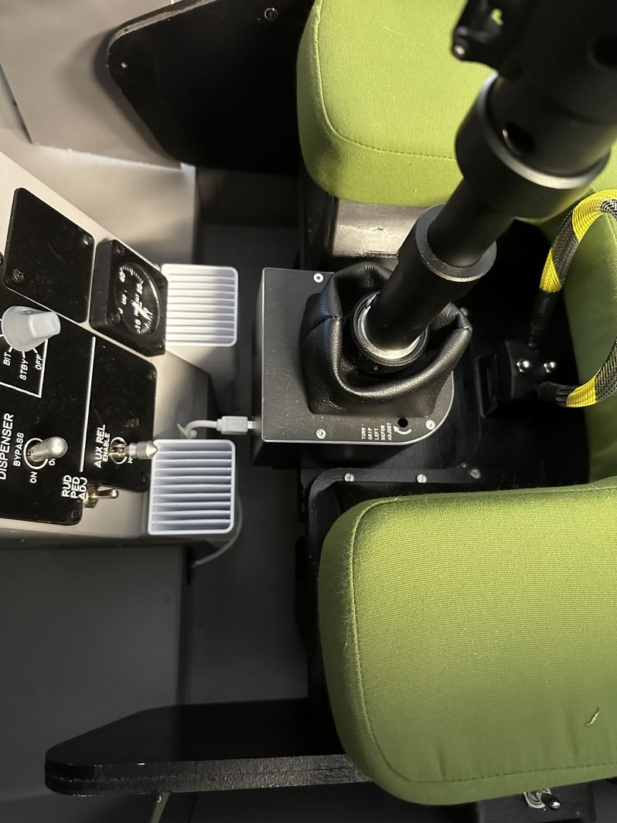
 | 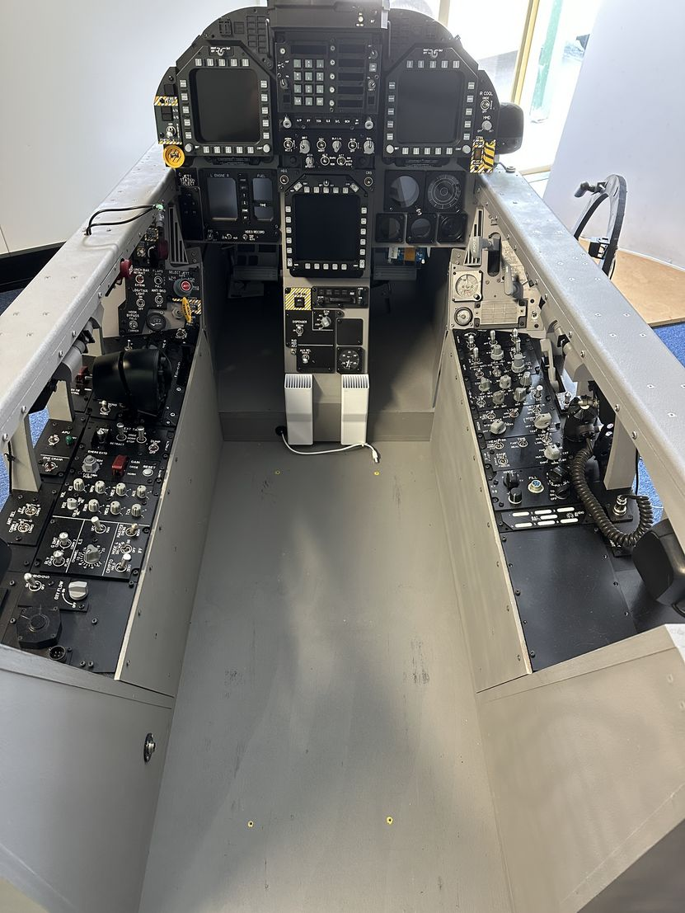

Disconnect Cable

Remove Rear Support Cross Member

Remove Seat Base Screws
Slide Seat Slightly back

Remove Stick USB cable

Lower seat rollers

Slide Seat out

The Forward Assembly is now standalone
